**Submission by the Republic of Korea**

**September 20, 2022**

**Views on the work programme under the framework for Non-Market Approaches referred to in Article 6, paragraph 8, of the Paris Agreement**

In response to the Call for Submission under the item Matters Relating to Article 6 of the Paris Agreement – 6.8; ROK is pleased to submit the inputs below on;

* Actions that facilitate the implementation of nationally determined contributions and can be identified, developed and implemented through the framework for NMAs.
* How NMA initiatives and programmes, consistent with the framework for NMAs have addressed the elements of chapter Ⅱ, paragraph 3(e), of the annex to decision4/CMA.3 and other relevant criteria determined by the participating Parties, as relevant.

The ROK hopes this submission could contribute to having a common and shared understanding of utilizing the REDD+ framework as a best practice and benchmarking target for program development in a Non-Market Approaches (NMAs).

**Background**

REDD+ seeks to reduce emissions from deforestation and forest degradation in developing countries while also promoting sustainable management of forest, enhancement of forest carbon stocks and conservation. Adopted as the Warsaw framework for REDD+ at COP16, REDD+ became officially recognized by UNFCCC as a mechanism for mitigation. When it was established during the Kyoto Protocol negotiations, REDD+ has aimed to financially compensate countries for emission reduction from deforestation and forest degradation. Article 5 of the Paris Agreement reflects this objective, and Article 4 and 6 have allowed Parties to achieve their NDC targets through REDD+. Currently 64 developing countries are involved in the the Warsaw framework for REDD+, and 13 countries so far have registered their results of emission reductions (Aug.2022). However, most developing countries are in dire need of support for capacity building in order to successfully implement REDD+.

REDD+ not only provides carbon benefits, but also contributes to non-carbon benefits such as biodiversity conservation, ecosystem services, and the quality of life of local communities. Moreover, environmental and social safeguards necessarily accompany in the process of implementing REDD+ as financial support, technology transfer, capacity building and other related activities occur. As a result, when considering these aspects, REDD+ activities can be leveraged not only as a market approach, but also as NMAs.

**Ⅰ. Actions that facilitate the implementation of nationally determined contributions and can be identified, developed and implemented through the framework for NMAs;**

According to NDC synthesis report(PA/CMA/2021/8) from UNFCCC, the vast majority of countries state that they require both technical and financial support in addition to capacity building when implementing NDC. Financial support, technology transfer for methodology development, system building and analysis capabilities for greenhouse gas reduction are carried out in the process of implementing REDD+. Resulting mitigation outcome from REDD+ can be used by Parties to meet their NDC targets in accordance with detailed guidance on Article 6 of the Paris Agreement finalized at COP26 (PA/CMA/2021/10/Add.1).

1. **The two-step approach to REDD+ based NDC achievement**

UNFCCC has specified three phases for implementing REDD+ (para73, Decision1/CP.16):

- The first phase, the Readiness phase, is where the host parties establish National Strategy or Action Plan with stakeholders, build capacity, and develop policies for REDD+ implementation

- The second phase, the Implementation phase, is where countries carry out their National Strategy or Action Plan. Included in this activity are results-based pilot tests, capacity building, and technology transfer. Pilot activities are implemented at the subnational level as a transitional step toward implementing the national-level REDD+.

- The third phase, the Full Implementation(result-based payment) phase, is where REDD+ actions are implemented at the national level and where results are fully monitored, reported, verified, and compensated.

While the first two phases of REDD+ fall under Article 6.8(NMAs), the third phase and its relevance to results-based activity may relate to Article 6.2(Cooperative approaches) with regard to internationally transferred mitigation outcomes (ITMO). Because the detailed activities of each phase for implementing REDD+ relate to many elements of NCD, carrying out these activities could play a pivotal role in promoting NDC goals.

* 1. **Detailed activities of REDD+ 1-2 phases linked to NDC under NMAs.**

1. **Adaptation**

The core of REDD+ initiatives is to prevent forest degradation and halt deforestation. As a result, it is important to create alternatives in the process such that stakeholders who are drivers of deforestation and forest degradation can adapt to new environments. These alternatives may include developing alternative livelihood models, improving productivity through sustainable forest management, among many others.

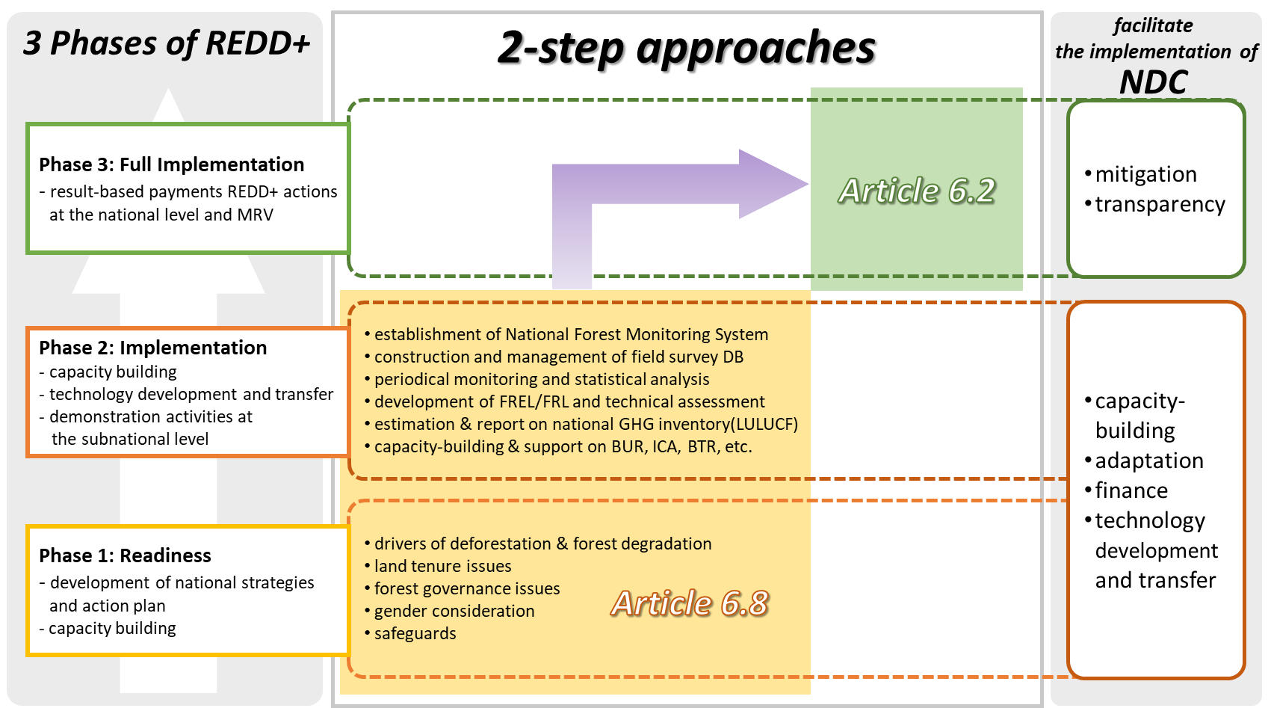

<figure 1> The two-step approach to REDD+ based NDC achievement

1. **Technology development and transfer**

The decisions on the Warsaw Framework for REDD+ require developing countries hoping to receive result-based payments via REDD+ to have the following: a.National Strategy/Action Plan, b.Forest Reference (Emission) Level, c.National Forest Monitoring System (NFMS), d.Safeguards Information Systems.

* **Forest Reference Emission Level / Forest Reference Level (FREL/FRL)**

GHG emissions and past levels of forest degradation and deforestation are estimated based on FR(E)L. Then expected emissions reduction resulting from REDD+ is calculated. As the most technical component among the four required for REDD+ activities, FR(E)L must be subject to rigorous evaluation standards. Because forest related data are required for establishing FR(E) L, National Forest Monitoring System will need to be developed.

* **National Forest Monitoring System (NFMS)**

The NFMS is used to provide information on national forest surveys and their data to enable MRV for implementing REDD+ activities. Forest area, coverage and types are estimated for REDD+ MRV. This is usually achieved through satellite remote sensing. Moreover, based on National Forest Inventory through field survey, forest carbon stocks are evaluated to determine forest carbon emissions from deforestation and forest degradation.

1. **Finance**

Financial support is crucial to implementing REDD+ activities under the NMAs framework and can be drawn from both private and public sectors. Especially in times where ESG management is becoming mandatory, a number of companies are striving to achieve ESG management and Corporate Social Responsibility (CSR) goals. Because REDD+ projects require forestry expertise, companies might face high entry barriers. However, companies can still participate in REDD+ projects by laying the groundwork via financial assistance.

1. **Non-carbon benefits**

UNFCCC has made safeguards a requirement for REDD+ implementation in order to prevent unintended socio-ecological consequences. These safeguards - such as biodiversity and natural forest conservation, land ownership issues and the rights of local people - are included in the National Strategy/Action Plan and Safeguards Information System among the four REDD+ bases of the Cancun Agreement (para71, 1/CP.16). In other words, REDD+ activities that actively consider these safeguards will create non-carbon benefits such as biodiversity conservation and improved quality of life for local people.

* 1. **Detailed activities of REDD+ 3 phases linked to NDC under NMAs.**

1. **Mitigation**

Based on the developing countries’ capacity to implement REDD+ created through NMAs during the first two phases of REDD+, the 3rd phase of REDD+ can be carried out as an international mitigation activity with host countries by switching to a cooperative approach under Article 6.2. The resulting ITMOs can be used toward both countries’ NDC emission targets. NMAs REDD+ activities thus can be seen as contributing to the achievement of global temperature target in that they not only foster implementation capabilities of partner countries through NMAs but also carry out activities that contribute to both countries’ NDC emission targets.

**Ⅱ. How NMA initiatives and programmes, consistent with the framework for NMAs have addressed the elements of** **chapter II, paragraph 3(e), of the annex to decision 4/CMA.3 and other relevant criteria determined by the participating Parties, as relevant.**

Chapter II, para3(e) of the annex to decision 4/CMA.3 states that NMA urges Parties to promote the rights of indigenous peoples, local communities as well as people in vulnerable situations and strengthen gender equality and women's rights, etc.

1. **REDD+ and the human rights**

Forests are a source of life for forest-dependent residents, and various assistance will be required to sustain their lives that are particularly vulnerable to climate change. A variety of stakeholders are intertwined in REDD+ activities, and at the center of these activities are local communities, residents and indigenous peoples. Strengthening safeguards, building communities’ capacity, strengthening their land tenure, formulating a rational land use plan, providing adequate financial support and creating a transparent information system are essential for a successful REDD+ implementation.

In this context, UNFCCC has required Parties to address the drivers of deforestation/degradation, land tenure issues, forest governance, gender issues, safeguards, and stakeholder engagement in their REDD+ National Strategy/Action Plan (para72, Decision1/ CP.16). This relates to some of the items included in chapter II, paragraph 3(e), of the annex to decision 4/CMA.3.

**- the rights of indigenous peoples, local communities**

The core activity of REDD+ is to identify and address drivers of deforestation and degradation. However, because this activity directly interferes with the lives of local people whose livelihood depends on forests, securing land tenure for these people can become an issue. In order to prevent these kinds of issue, UNFCCC clarifies that REDD+ should be implemented at a level that respects the rights of indigenous and local people while also respecting their traditional knowledge (para2(c), Annex I, Decision1/CP.16). UNFCCC also encourages the development of guidelines that allow for effective participation of indigenous and local people in monitoring and reporting (para3, Decision4/CP.15).

**- gender equality, empowerment of women**

The issue of gender inequality and women’s empowerment have been continuously emphasized in REDD+ discourses. This is because women in many developing countries are socio-economically disadvantaged. Ironically, however, traditional knowledges and experiences regarding forestry and livelihoods have been passed down to women. As a result, women are often key to addressing drivers of deforestation/degradation when implementing REDD+. In fact, a great deal of REDD+ activities that have been implemented globally are actively raising awareness around gender and women-related issues in support of women’s rights and empowerment.

1. **Application of REDD+ Safeguards Information System for the human rights obligations under NMAs**

The UNFCCC has specified through the Safeguards Information System (SIS) that the seven REDD+ safeguards stipulated in the Cancun Agreement should provide a summary of how they are being handled and monitored throughout the REDD+ implementation (Decision12/CP.17 and Decision12/CP.19). These safeguards include forest governance, respect for knowledge and the rights of indigenous and local communities, as well as effective participation of various stakeholders (Annex I, Decision1/CP.16). A summary information on safeguards is regularly submitted via NC or BUR to be transparently disclosed to the REDD+ web platform (para2, Decision12/CP.19). NFMS as well can be used to provide safeguards information (para5, Decision11/ CP.19).

Through long negotiations, UNFCCC has not only developed guidelines for REDD+ safeguards, but also a system for reporting progress details periodically and disclosing these details transparently. Safeguards covered by REDD+ SIS do not include all the elements of human rights which mentioned in annex to decision 4/CMA.3. However, using the REDD+ SIS, in which many developing countries are already involved, and expanding the scope of the target will be an effective way to build a system for achieving NMA's human rights obligations.

**Conclusion**

Parties are joining forces to discuss what programs could be implemented under Article 6.8 of the NMA framework. REDD+ is a mitigation mechanism that also requires compliance to safeguards during the implementation process. REDD+ implementation phases already include non-market approach activities, which are an excellent example of NMAs and will help Parties achieve NDC targets. Moreover, because REDD+ activities as NMAs serve as a basis for Internationally transferred mitigation outcomes between Parties via cooperative approach, they are proposed as a benchmark model for linking Articles 6.8 and 6.2.